**Disable and Enable a Network Connection and Then Diagnose a Connectivity Problem**

**Time Required:** Approximately 10 minutes

**Objective:** Learn how to disable and enable a network connection to reset it and how to

diagnose a connectivity problem.

**Description:** In this activity, you disable your own network connection and then enable the connection as practice in resetting a hung connection. You also practice using the diagnostic tool to troubleshoot a connection problem. Before starting, use Task Manager to make sure no one is signed in to the server you use for practice.

1. Right-click **Start** and click **Network Connections**.
2. Right-click the connection, such as Ethernet, and click **Disable**.

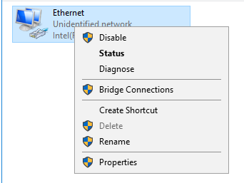

1. Right-click the connection again and click **Enable**.
2. To practice using the connection diagnostic, right-click the network connection and click **Disable**.
3. Right-click the connection and click **Diagnose this connection**.

* Briefly describe what happens.

1. Click **Close** in the Windows Network Diagnostics box.
2. Close the Network Connections window.